ELEC 2210 Fall 2020

Lab 4 Quiz

Name: Jacob Howard

Section: 002 (Tues 1:00pm)

1. What is the difference between a half-adder and a full-adder?
2. Carry out
3. **Carry in (Full adder has carry in)**
4. Carry out and Carry in
5. Sum
6. Convert the decimal number 50 into binary and hexadecimal.

Dec to Bin = 110010

Dec to Hex = 32

1. What is the sum of binary numbers 110010 and 101111?

**Binary = 1100001**

**Dec = 97**

**Prelab Screenshots**

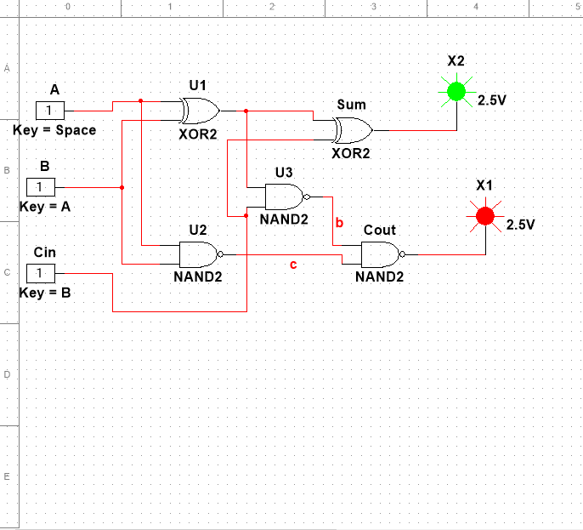

|  |
| --- |
| **C** |
| **C** |
| **C** |
| **C** |
| **C** |
| **C** |
| **C** |
| **C** |

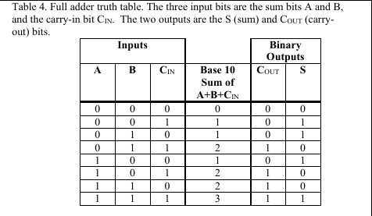

**C is for correct. The truth table checks out**

